View and triggers
A view can also be modified or removed when it is no longer required. The DROP VIEW command is used to permanently remove a view. For example, DROP VIEW student_details; deletes the view without deleting the original Student table. Therefore, views provide a convenient way to display selected information from database tables.
A Join is an SQL operation used to combine data from two or more tables based on a related column. Joins are important in relational databases because information is usually divided into multiple tables to avoid unnecessary duplication. By using joins, we can retrieve related information from these tables in a single query.
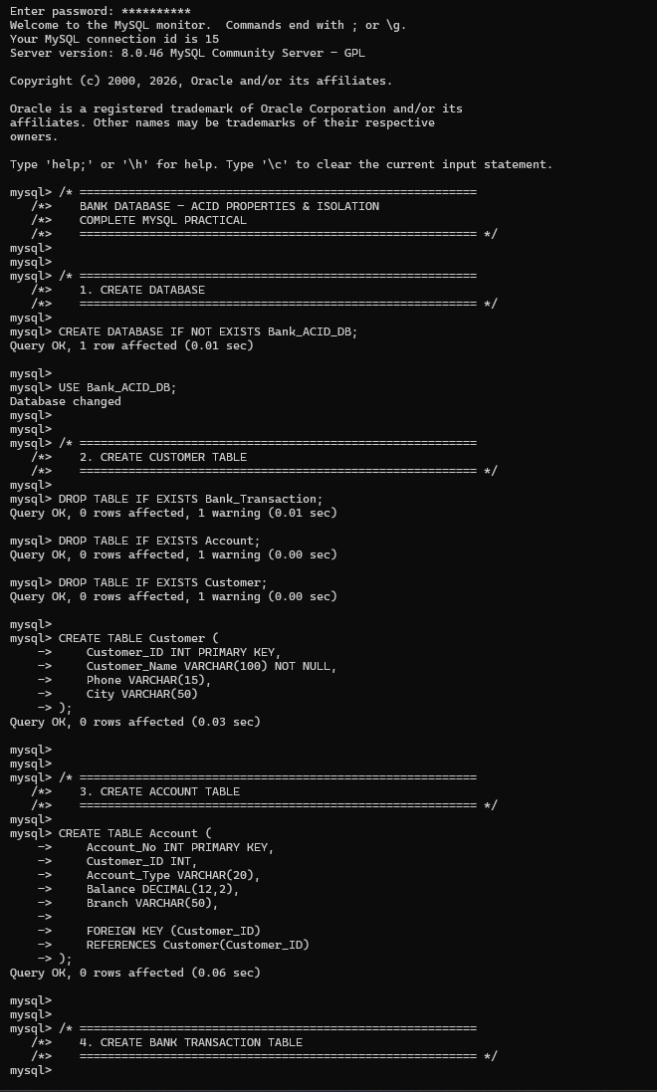
A Trigger is a special type of stored program that automatically executes when a particular event occurs in a database table. Triggers are commonly associated with operations such as INSERT, UPDATE, and DELETE. They are useful when we want the database to automatically perform an action whenever data is inserted, modified, or deleted.
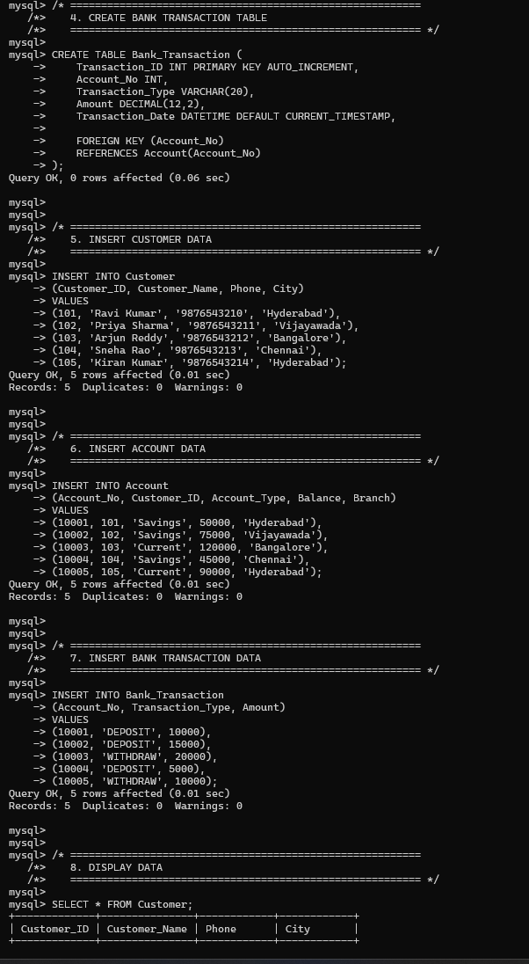
For example, a trigger can be created to automatically store a record in an audit table whenever a student record is updated. This means the programmer does not have to manually insert the audit information every time an update occurs. The trigger automatically performs the required action.
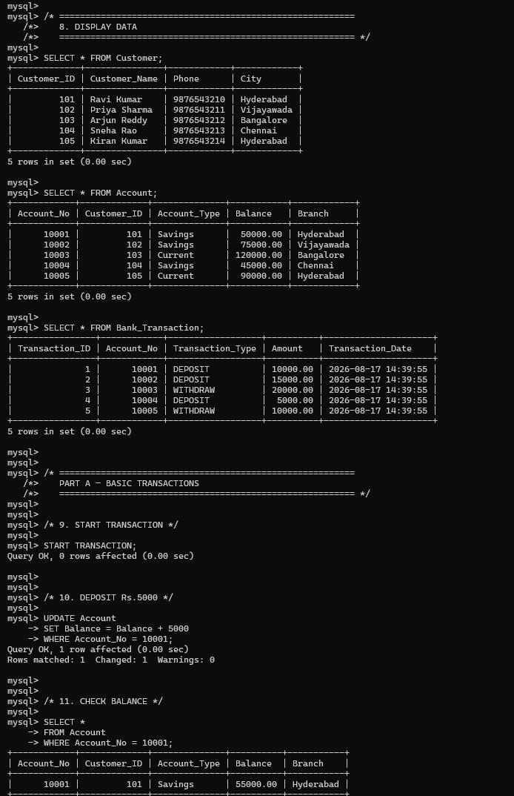
Triggers can be executed BEFORE or AFTER a particular operation. A BEFORE INSERT trigger executes before a new record is inserted, while an AFTER INSERT trigger executes after the record has been inserted. Similarly, triggers can be created for update and delete operations. Triggers are useful for maintaining data integrity, creating audit records, and automating database operations.
